2222
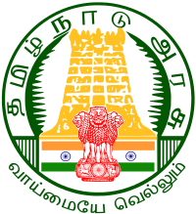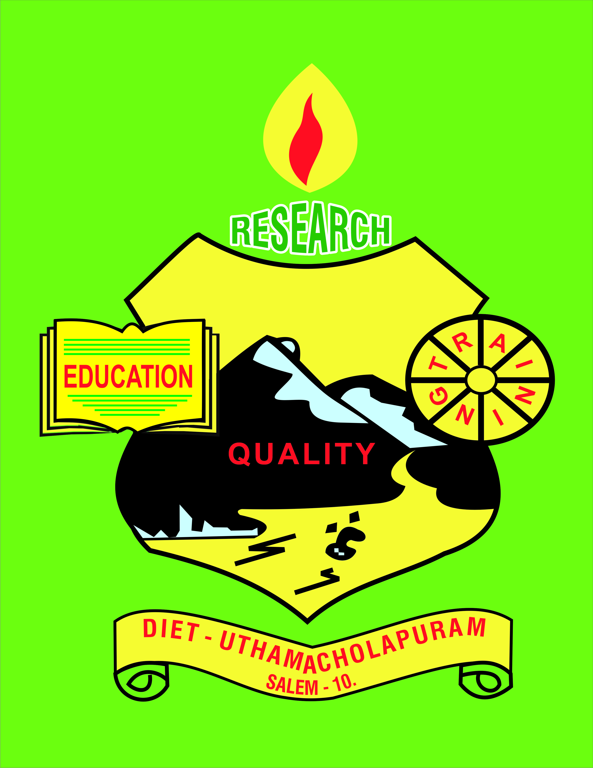

Uthamacholapuram, Salem-636010
October– 2022 PREPARED BY: Publication Division Vol.No.5 S.No.10
Vol: No:

SPECTRUM
ECHO OF DIET SALEM
EE
Ece

Awareness of Educational Rese

History of Wireless communication – Morse Code to 5G Technology
The earliest form of communication was smoke signals. These were used by Native Americans and other indigenous peoples to communicate over long distances. The history of wireless communication can be traced back to the late 1800s when scientists started experimenting with electromagnetic waves. Find out the history of wireless communication, and progress from Morse code to 5G technology during the past decades.
The history of wireless communications starts in the 19th century with the theoretical prediction of electromagnetic waves by James Clark Maxwell in the 1860s. Two decades later, it was experimentally proved by Heinrich Hertz in 1888.
Real-world applications of wireless communication started during the end of the 19th century with the invention of the world’s first wireless communication device and started an evolution in technology.
Morse code :
The first form of communication started after the invention of the Morse code by Samuel F B Morse in the 1830s. It uses different signal lengths to encode characters known as “dot” and “dash” (with dot – shorter and dash – longer duration of signals). This encoded message will be sent via a wired medium and will be interpreted at the receiving end by a person simply by listening to the sequence received.

History of Wireless communication
The limitations of wired channels for long-distance communication lead us to continue experiments on wireless medium for information interchange. It eventually trigger engineers and inventors to develop an efficient way of communication using wireless technology.

1890s – First Wireless Communication

Wireless Telegraph
The first wireless telegraph system was invented by Italian engineer Guglielmo Marconi in 1896. He demonstrated a newly developed device by sending radio signals across the Atlantic Ocean and received it successfully.
Marconi improved his telegraph further and holds 800 wireless patents. Later this technology has proved its significance in the history of events. SOS signals from the sinking Titanic was received by nearby ships and 700 peoples were rescued. It was the most efficient form of distress signal during that period of time.

1900s – First Radio Broadcast
Radio transmission
Marconi’s invention was accepted by many radio enthusiasts and many people started to develop different variants of radio transmission devices across the USA and Europe during the early 20th century. In December 1906, Canadian radio experimenter send music and talks for one hour, and people were able to listen using their wireless receivers. This was the first radio broadcast.

1920s – First Commercial Radio
Commercial Radio Broadcast
In the UK, the first commercial radio broadcast began on 15th June 1920 with Australian opera singer Dame Nellie Melba’s song on the radio.

1930s – Radar technology, Television Broadcasting
Radar
Radar development began in the 1930s, with the work of several scientists in several countries. The first experimental radar system was built in England in 1935.
Television Broadcasting
The first commercial television broadcasting started in the US on July 2, 1928. They have used 1605 kHz and 6420 kHz frequencies in the beginning and later at 2.0 to 2.1 MHz range. Non- experimental TV broadcasted started in Germany in 1935 and one year later in England by British Broadcasting Corporation (BBC).
Satellite Television Broadcasting
BBC is the first organization to start broadcasting signals using satellite on 25th June 1967, three decades after the first on-air program.

1940s – Quality Radio Services
FM Radio Broadcasting
The new technique used Frequency Modulation (FM) and was thus later known as FM radio stations. In simple words, FM is a technique of changing the frequency of the carrier signal according to the amplitude of the sound signal.

1950s – First Satellites, the Space program
Satellites
The first-ever artificial satellite was Sputnik 1, launched by Russia (then known as the Soviet Union) in 1957. This historic event marked the start of the “Space Race” between the Soviet Union and the United States. The first generation of satellites was used primarily for communications and television. They were large and bulky, and could only stay in orbit for a limited amount of time.
1970s – Mobile networks, GPS
Cellular Phone
The first cellular phone was developed in 1973 by Dr. Martin Cooper of Motorola. The first call was made on a prototype Motorola handset on April 3, 1973.
Global Positioning System
GPS, or the Global Positioning System, is a space-based navigation system that provides precise location and time information to users on the ground. The first GPS was launched in 1978, and it revolutionized navigation for both civilian and military users.

1980s – First-generation mobile networks
The first generation (1G) of mobile networks was an analog technology that was launched in the 1980s. This first generation mobile network was very slow by today’s standards, with data speeds of only a few kilobits per second (kbps). Despite its slower data speeds, 1G was a breakthrough at the time because it allowed people to make phone calls and text messages from almost anywhere.

1990s – Second-generation mobile networks, Wi-Fi

The second-generation (2G) of mobile networks was a digital technology that launched in the early 1990s. 2G increased data speeds to a few hundred kbps and also introduced new features such as text messaging.
The fourth-generation (4G) of mobile networks was a digital technology that launched in the 2010s. 4G increased data speeds to a few tens of Mbps and introduced new features such as high-definition (HD) video streaming.

Wi-Fi Network
The advent of the internet has led to several technological advancements, one of which is Wi-Fi. The first generation of wireless standards (IEEE 802.11) was finalized in 1997 and released in the same year. Wi-Fi allows devices to connect to the internet wirelessly, using radio waves.
This technology has become popular since its first release, as it eliminates the need for cables and makes internet access more convenient. Wi-Fi is considered one of the most popular and widely used technologies across the world.

2000s – Satellite internet, 3G Networks
Satellite internet
Satellite internet technology has revolutionized the way that people access the internet. The first satellite internet service for customers started service in September 2003. Rather than being limited to a single connection to the internet, people can now connect to the internet anywhere in the world with a satellite dish and an internet-ready device.
3G – Third Generation Mobile networks
The third-Generation (3G) of mobile networks was also a digital technology that launched in the early 2000s. 3G increased data speeds to a few megabits per second (Mbps) and introduced new features such as mobile broadband Internet access.

2010s – LTE advanced, 5G network
The 5G – the fifth-generation mobile networks are the latest generation of wireless technology which revolutionized the way we use our mobile devices. The first 5G networks were deployed in 2019 and it is still in progress across the globe.
5G networks are faster, more efficient, and more secure than their predecessors, and they will open up a whole new world of possibilities for mobile users.

Future of Wireless Communication
Wireless technology has been continuously evolving ever since the first communication using Morse code, now at 5G a century later. Researchers are currently studying the possibilities of 6G technology for future wireless networks. Analysts predict that the early implementation of 6G technology will be ready by the year 2030.

Dr M.Selvam - Principal
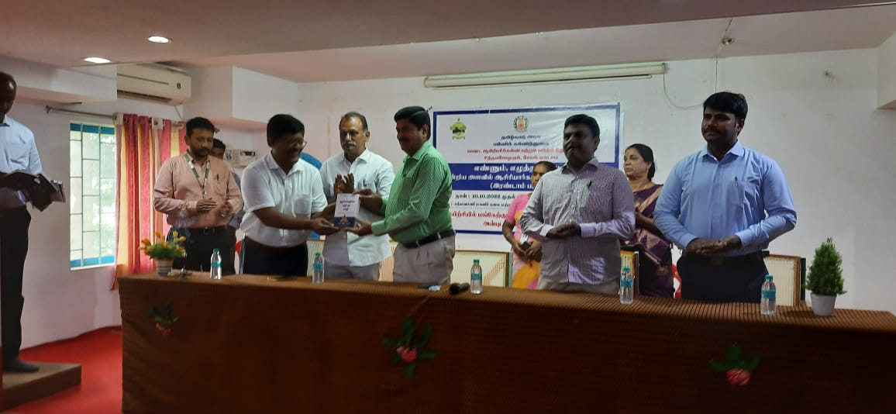
- Participated in the ‘District Level Meeting’ on ‘Ennum Ezhuthum -II’, Which was Organized by CEO at Cluny School, Salem on 06.10.2022.
- Visited Ennum Ezhuthum Union Training – Padmavani College, CSI TTI, CSI Polytechnic, KIOT on 10.10.2022 ; Swamy CBSE School, Vaigai Matric School, Valapady, GET Excell Matric School, Gangavalli GHSS, PN Palayam on 11.10.2022 and Jayajothi Educational College, Veda Vikas Matric School, Santhiyur, Kaveri College of Physiotheraphy, Mecheri on 12.10.2022.
- Participated in the workshop on ‘Developing Resource for Tamil Nadu Leadership program for HMs’ at Pillar Hall, Madurai from 13.10.2022 to 14.10.2022.
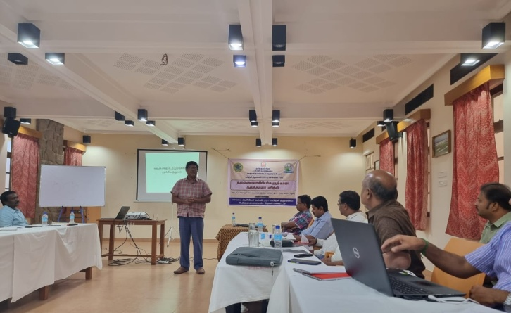

- Organized Pre-Planning meeting for video shooting on ‘Classroom Observation’ at GHSS, Aragalur on 17.10.2022 and video shoot on 19.10.2022.
- Participated in the ‘Nann Mudlvan’ program at Holy Angels, Salem on 20.10.2022.
- Accompanied with the member Mr.R.Balu, HM, PUMS, Keechamkuppam, Tamil Nadu New Education policy for visiting schools PUMS, C.Thathanur, PUPS, Thukkiyampalaym, TR school, Karumanthurai, GHSS, Aragalur on 27.10.2022 and attended TNNEP meeting at Collectorate on 28.10.2022
- Visited CRC training centres – GHSS, Mettur, Kolathur on 29.10.2022.

PRE – SERVICE TEACHER EDUCATION : (PSTE)
Dr P.Govinda Prakash - Senoir Lecturer
07.10.2022-  to  12.10.2022 | Ennum Ezhuthum –Term II Block Level Training Preparation work was seen.  Organized and Coordinated Ennum Ezhuthum –Term-II Training Programme at Salem Rural Block for Primary Teachers.

Mrs. S.Selvi - Lecturer
- 3-10-22, 6-10-22&7-10-22-Ennum Ezhuthum” –Term-II Training Programme preparation work was seen at Knowledge Institute of Technology, Kakapalayam, Salem.
- 10-10-22, 11-10-22 &12-10-22 – Acted as a Co-ordinator in Ennum Ezhuthum-Term-II Training Programme at Knowledge Institute of Technology, Kakapalayam, Salem.
- 14-10-22 & 26-10-22 – “Ennum Ezhuthum” training programme bills prepared and submitted to DIET office.
- 31-10-22 – Capacity Building training attended at Pillar Hall, Nagamalai Pudukottai, Madurai.
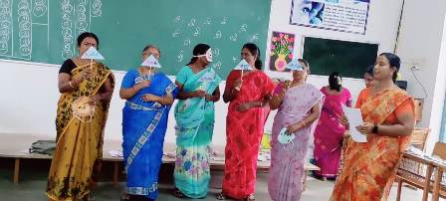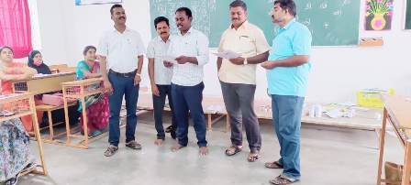
Dr S.Peter Anandh - Lecturer
- 10.11.22 to 12.10.22-Orgnized and Coordinated Ennum Ezhuthum-Term-II Block Level Training Programme for Primary Teachers at Yercaud Block .
- 14.10.22-Ennum Ezhuthum Training bills and expenditures submitted to DIET office.
- 29.10.22-Attended CRC training centre at Yercaud block.
Mr. R.Ravi - Lecturer
- 03.10.2022- Attended “Ennum Ezhuthum” Meeting and Visited NSIT, Salem Centre.
- 06.10.2022- Visited NSIT, Salem for Ennum Ezhuthum work carried out.
- 07.10.2022- Ennum Ezhuthum training arrangement work carried out at NSIT, Salem.
- 10.10.2022- Conducted Block level Ennum Ezhuthum –Term II –Tamil subject Training programme at NSIT College, Poosaripatti, Salem.
- 11.10.2022-Conducted Block level Ennum Ezhuthum –Term II –English subject Training programme at NSIT College, Poosaripatti, Salem.
- 12.10.2022-Conducted Block level Ennum Ezhuthum –Term II –Mathematics subject Training programme at NSIT College, Poosaripatti, Salem.
- 17.10.2022-Ennum Ezhuthum –Term II Documentation work was done at DIET.
- 18.10.2022- Visited ITK Centre at Kadayampatti Block.
- 19.10.2022-Visited school for Ennum Ezhuthum activities at PUMS, Varichiyur, Kadayampatti Block.
- 21.10.2022-Visited school for Ennum Ezhuthum activities at PUES, Kongupatti, Kadayampatti Block.
- 26.10.2022-Ennum Ezhuthum Documentation Work was seen at DIET/Verified and Issued Certificates to Private TTI.
- Visited ITK Centre at Kadayampatti Block.
- 28.10.2022-Visited school for Ennum Ezhuthum activities at PUES, Deevetipatti,, Kadayampatti Block.
- 29.10.2022-Visited and Attended CRC meeting at Pannapatti, GHSS, Kadayampatti Block.

IN-SERVICE, FIELD INTRACTION INNAVATION AND COORDINATION: (IFIC)
Dr K. Ramesh Kumar-Lecturer
01.10.2022 & 03.10.2022
Organized TLM Preparation workshop for block level Ennum Ezhuthum training at Padmavani College of Arts and Science.
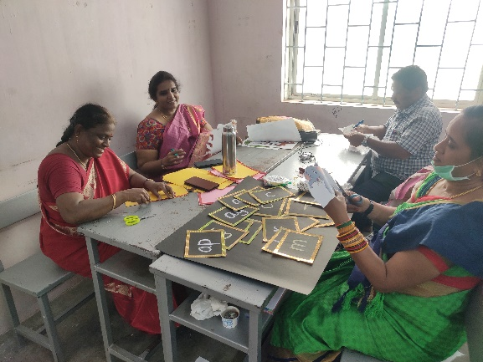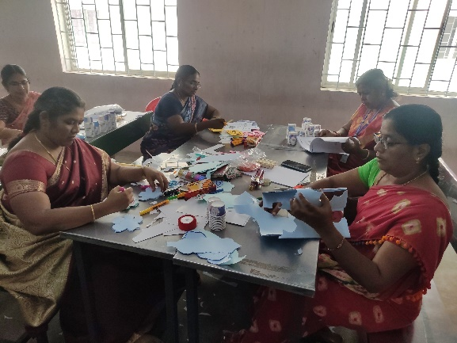
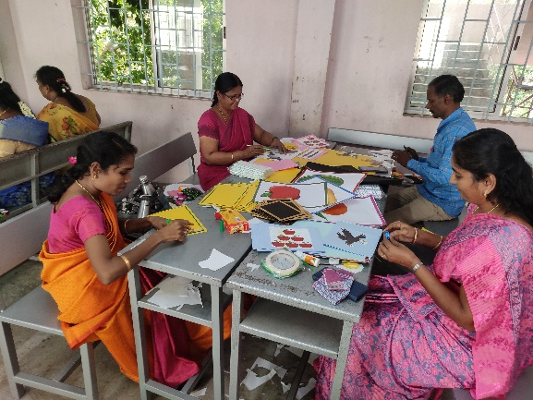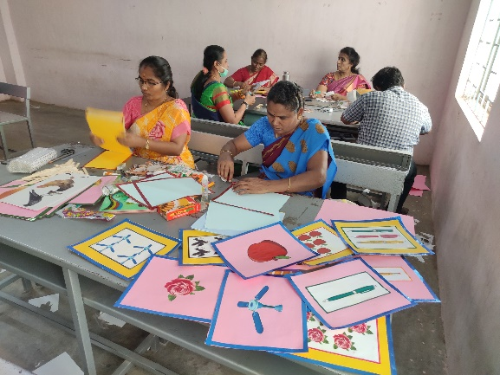
06.10.2022 & 07.10.2022
Organized Video Recording workshop for TLM preparation with resource person K.Bakyalakshmi.
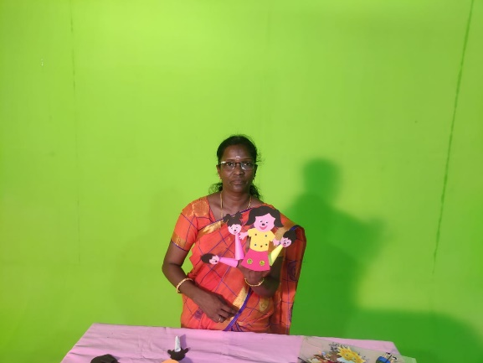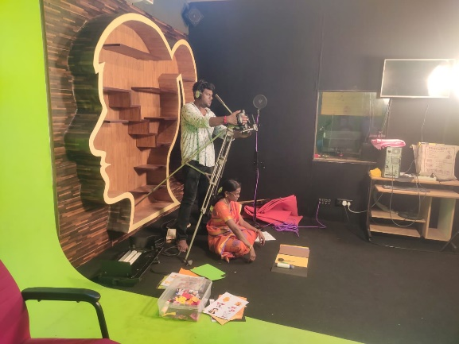
10.10.2022 , 11.10.2022 & 12.10.2022
Organized block level Ennum Ezhuthum training at Bathmavani College of Arts and Science. The inaugural ceremony of the Block Level Enum Ezhuthum Training commenced with the lighting of lamp by a group of dignitaries of School Education – Dr V. Kumar (Joint Director (Traimning), SCERT, Tamil Nadu), Mr Murugan (Chief Educational Officer, Salem), Dr M.Selvam (Principal, District Institute of Education and training, Uthamacholapuram, Salem), Mr G.Santhosh (District Educational Officer, Salem), Mr Sathiyamoorthi (Chairman, Padmavani Educational Institutions),
Dr Harikrishnan (Principal, Padmavani Arts and Science College for Woman) and Dr Muthukumar (Principal, Padmavani College of Education for Woman). The program was followed by Tamilthai Vazthu.
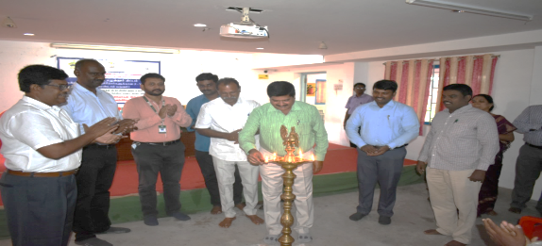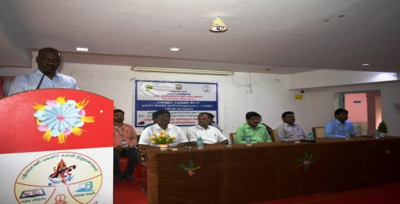
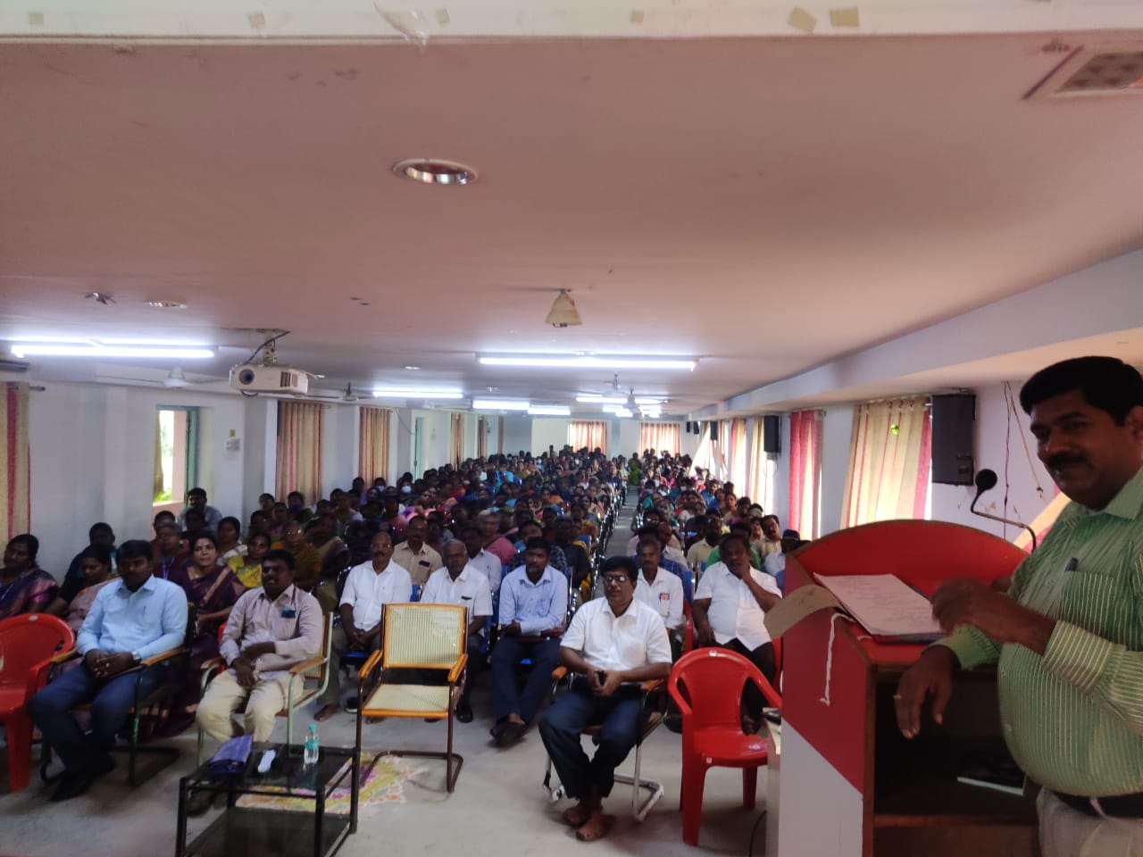
19.10.2022
Organized Video Recording workshop in GHSS Aragalur on Classroom Observation with resource persons/Teachers Mrs Kalaiarasi, Mrs Indra and HM Mr Rajendran.
27.10.2022
Accompanied School visit with State Education Policy Member Keechankuppam Balu and DIET Principal. Visited Schools PUES ViDhadanur, PUES Thukiyampaliyam, ADTW GHSS Karumandurai and GHSS Aragalur.
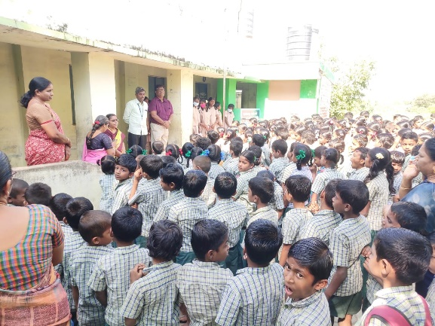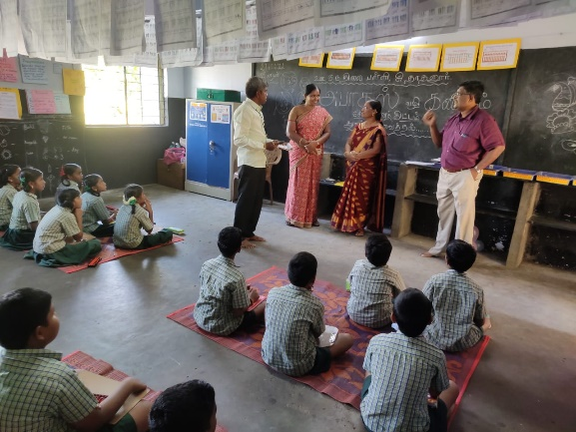
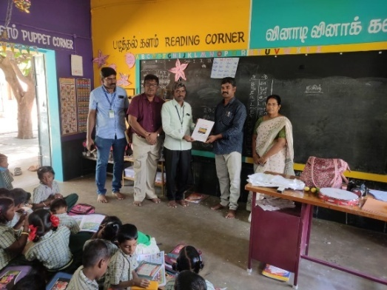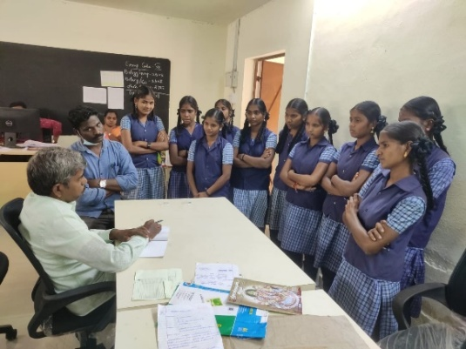
28.10.2022
Attended Regional meeting convened by members of State Educational Policy in Salem Collectorate.
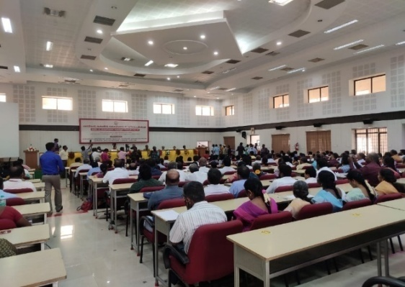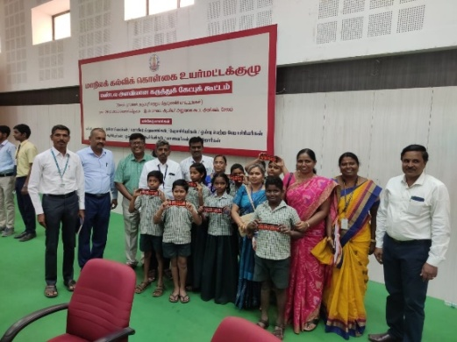
Mrs. M. Mahalakshmi - Lecturer
- 07.10.2022-Organized and Arranged TLM Preparation work for Ennum Ezhuthum –Term II Block level at BRC-PN Palayam, Salem.
- 10.10.2022 to 12.10.2022-Cordinated and Organized Ennum Ezhuthum-Term II-training Programme for primary and Upper primary teachers at Vidya Vidyalaya M.H. School,
PN Palayam, Salem.
- 27.10.2022-Visited Schools for ABACUS Kit Programme at PUMS, Thathanoor and PUES, Thukiampalayam, Salem.
- 28.10.2022-Attended State Level Education Policy Review Meeting at Collectorate, Salem.
- 29.10.2022-Visited CRC centre at BRC, PN Palayam, Salem.
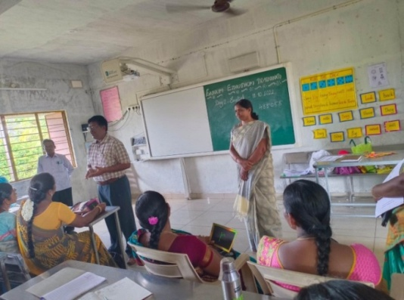
Educational Technology Branch: (E T)
Dr G.Dhanammal - Senior Lecturer
- 03.10.2022 to 06.10.2022-Pre Planning for Ennum Ezhuthum Training Venue Fixation.
- Arrangments were made for Ennum Ezhuthum–Term-II training programme at Sri Sakthi Matriculation Hr.Sec.School, Vanavasi, Nagavalli Block, Salem.
- 10.10.2022 to 12.10.2022- Coordinated and Organized Ennum Ezhuthum –Term II Training programme for Primary Teachers at Sri Sakthi Matriculation Hr. Sec. School, Vanavasi, Nangavalli Block, Salem.
- 22.10.2022-Visited CRC programme centre at Azhaagapuram Pudur, Salem Rural Block.
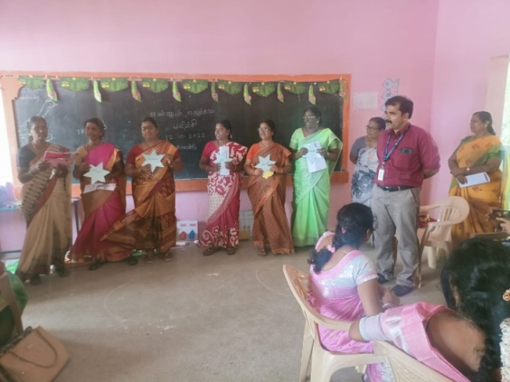
Mrs. M.Jayamani-Lecturer
- 04.10.2022: Attended “Ennum Ezhuthum”-Term-II Training for Resource Person Programme at Sowdeswari College , Salem.
- 07.10.2022: Pre Planning and Venue arrangements made for “Ennum Ezhuthum” Term-II training programme at Edappadi Block.
- 10.10.2022 to 12.10.2022 - Acted as Coordinator for “Ennum Ezhuthum” Term-II training programme at Wisdom Matriculation Higher Secondary School, Edappadi.
- 20.10.2022: Newsletter consolidation work was seen at DIET.
- 21.10.2022: Digital Content preparation work was seen at DIET.
Dr V.Suganya-Lecturer
- 03.10.2022- Carried out e-Office Work at DIET.
- 06.10.2022- Attended e-Office online meeting conducted by JD(Admin), SCERT-Chennai.
- 07.10.2022-Preplanning, Training Venue Fixation and Arrangements works for Ennum Ezhuthum -Term II were done.
- 10.10.2022 to 14.10.2022- Acted as coordinator for Ennum Ezhuthum -Term II training programme at Sri Swamy International School, Ayothiyapattinam Block.
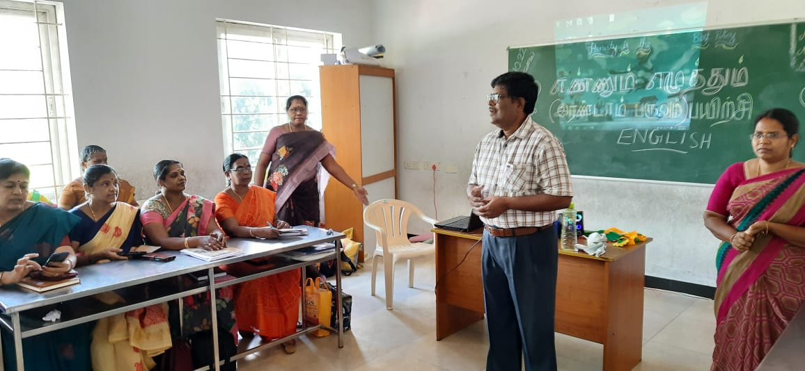
- 13.10.2022 & 14.10.2022- Ennum Ezhuthum-Term II vouchers prepared and submitted to office.
- 17.10.2022- Attended Salem DEO collaboration meeting and presented to ET branch activities and work.
- 19.10.2022- HM’s Training Video Shooting at GHSS, Aragallur, Thalaivasal Block.
- 27.10.2022- Visited Mariyamman Pudhur School, Ayothiyapattinam Block.
- 28.10.2022- Attended Stated Education Policy meeting at collectorate, Salem.
- 31.10.2022- DIET consolidation work was seen.
Curriculam, Materials Development and Evaluation Branch : (CMDE)
Dr R. Nagalakshmi-SeniorLecturer
- Acted as a co-ordinator in Ennum Ezhuthum –Term-II Training at Vaigai Matric Higher Secondary School, Valapady from October 10-12.
- Acted as a Resource person in Personality Development Programme in Kongunadu
College of Education , on 13-10-2022.
- Assessment cell work- MCQ generation for class 11th std & 12th std (Textile Dress Designing, Basic Civil Engineering & Chemistry) and for class 6th - Mathematics from October 19-21.2022 was seen.
- Assessment cell work was seen for - MCQ Curation work for class 11 & 12 ( Textile Dress Designing),Questions Prepared for Basic Civil Engineering subject and Chemistry subject/ Mathematics for class 6- on 26-10-2022.
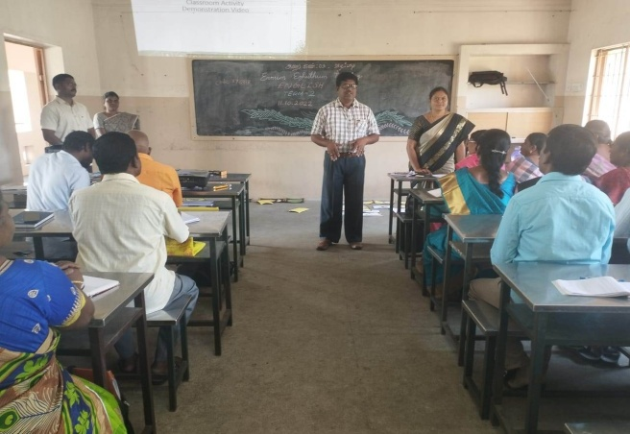

Dr. B.Ananthi, Lecturer
1. Participated in the Experts' Review Meeting for Dictionary Work, held at Asha Nivas,
Co-ordinated by SCERT, Chennai on 11/10/22.
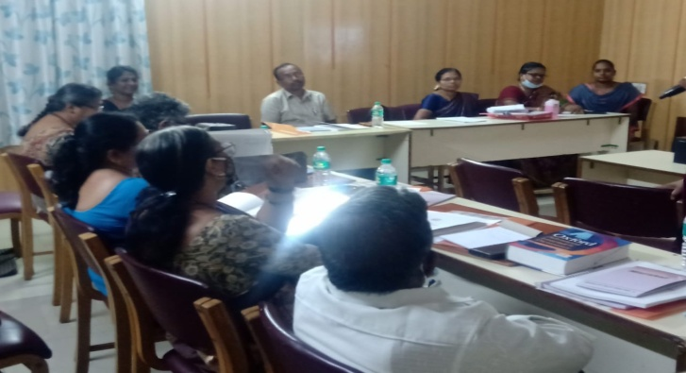
2. Participated in the Discussion Meeting held by DEO (Elementary), at DIET on 17/10/22.
3. Participated and contributed in the Dictionary Review and Pruning workshop, headed by
Dr. K. Sankar Ganesh, IRS, Joint Commissioner, Income Tax Department, Bangalore, at DIET, Salem on 21/10/22.
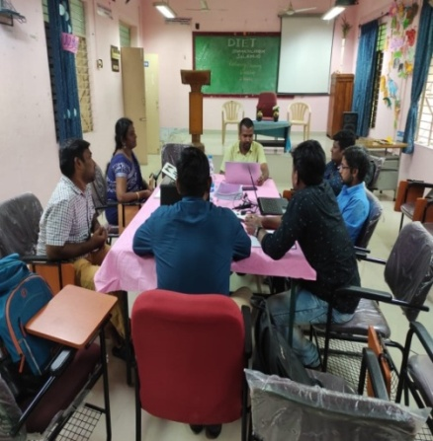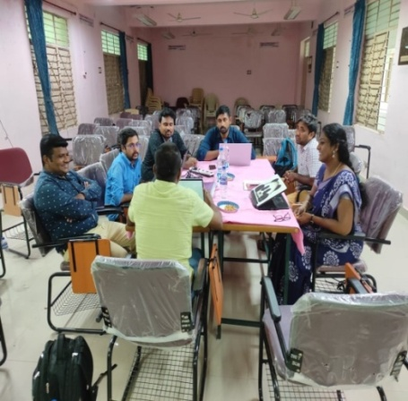
4. Visited CRC (Std 6 - 10) Centre at GHSS, Katchupalli, Konganapuram Block, Salem on 29/10/22.
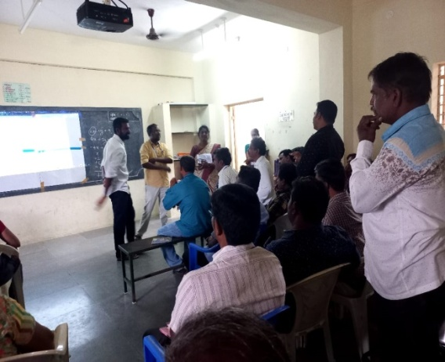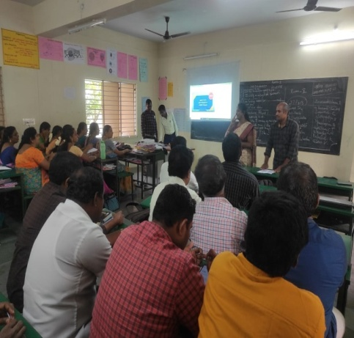

District Resource Unit : (DRU)
Dr T.Prabakaran-Senior Lecturer
- 7.10.22- Pre-Planning work was seen for Ennum Ezhuthum Term II and Fixed venue for Ennum Ezhuthum training programme, Panamarathupatti Block.
- 10.10.22 to 12.10.22-Organized and Coordinated “Ennum Ezhuthum” Term - II block level training programme for primary teachers at Vedha Vikas Matriculation Hr. Sec. School Malloor, Panamarathupatti block, Salem.
- 18.10.22 to 21.10.22- Coordinated BME Taxonomy work and uploaded in web portal at DIET.
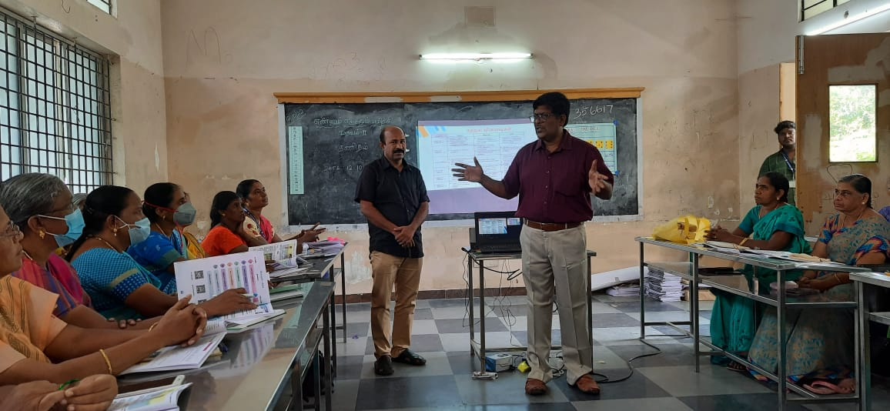

Dr P.So.Kesavan-Lecturer
- Coordinated Ennum Eluthum (2ndTerm) Training at VSA Engineering College, Uthmasolapuram, Salem from 10.10.22 to 12.10.22 (3 days)
- Ennum Eluthum (2ndTerm) Training at VSA Engineering College, Uthmasolapuram, Salem.
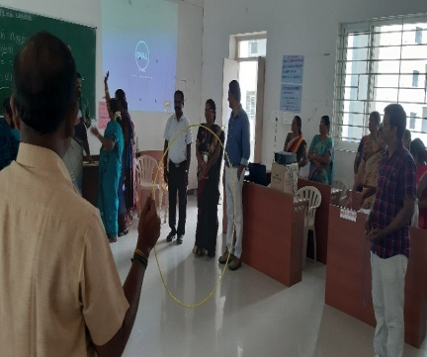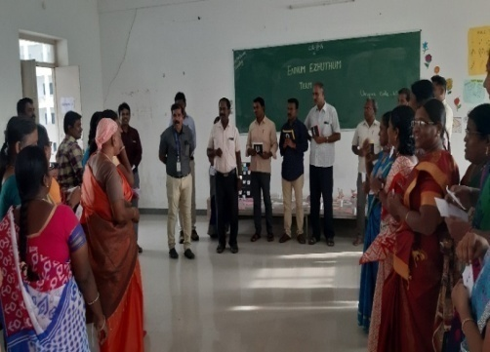
- Attended online meeting regarding MCQ’s preparation work and uploaded in the EMIS portal by SCERT- Assessment Cell on 19.10.2022.
- Coordinated and Prepared MCQs for Class 11- Textile and Dress Designing both in Tamil and English medium and also uploaded the questions in the EMIS portal on 20.10.22 and 21.10.22.
- Acted as an Officer on Special Duty for NIOS SEC/ SENIOR SECONDARY examination at Sri Seshaas Public School, Salem on 21.10.22.
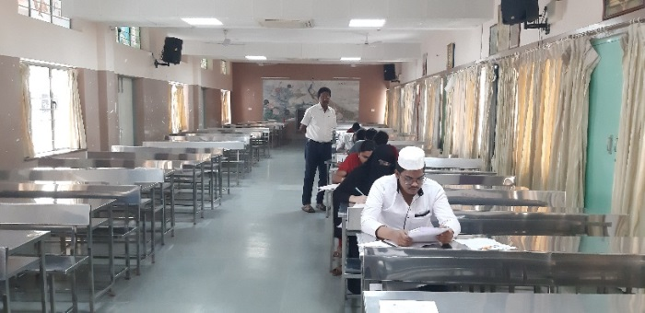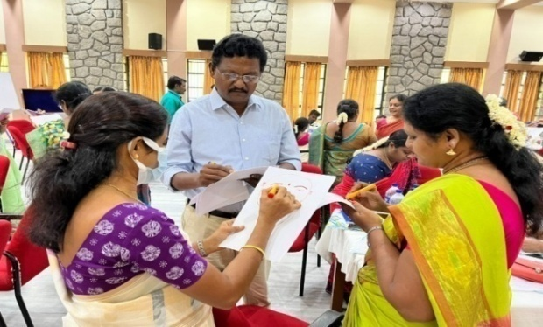
- Attended and Participated in PSD Training-Essential Themes (2 Phase) at Pillar Training Centre, Madurai from 31.10.22 to 4.11.22. PSD Training-Essential Themes (2 Phase) at Pillar Training Centre, Madurai
- PSD Training-Essential Themes (2 Phase) at Pillar Training Centre, Madurai
Planning and Management:( P&M)
Dr K.Kannaki - Senior Lecturer
- 7.10.22- Pre-Planning work was seen for Ennum Ezhuthum-Term II and Fixed venue for training programme.
- 10.10.22 to 12.10.22-Organized and Coordinated “Ennum Ezhuthum” Term-II block level training programme for primary teachers at CSI-Polytechnic, Hasthampatti, Salem.
Mr. B.Uthayakumar-Lecturer
- 7.10.22- Pre-Planning work was seen for Ennum Ezhuthum Term II and Fixed venue for training programme.
- 10.10.22 to 12.10.22-Organized and Coordinated “Ennum Ezhuthum” Term-II block level training programme for primary teachers at Sri Sathyam Collge of Engineering, Sankagiri Block, Salem.
- 13.10.22 to 17,10.22- Organized and Co ordinate Video Content Mapping for 11th and 12thStd at DIET, Salem.
- 31.10.22 to 03.11.22- Attended Capacity Building Training for DIET Faculty Members at Pillar Hall, Madurai by Azim Premji University, Bengaluru Resource Persons.

Work Experience : (WE)
Dr.Vijayalakmi Shankar-Senior Lecturer
Date | ACTIVITIES
06.10.2022 | Planning work for Ennum Ezhuthum Programme was seen.
07.10.2022 | Pre Planning work- for Ennum Ezhuthum Training at Sri Jaya jothi College of Education, Tharamangalam Block was seen.
09.10.2022 | Conducted online meeting through Google Meet for -AASAN AVAI -45th Special programme-DIET & Rotary MOU -Resource Person : Mrs. Devipriya, Psychologist, Helix School, salem Topic: Teaching Sentence Writing Strategy.
10.10.2022 | Acted as a Coordinator for Tamil Subject Ennum Ezhuthum Training at Sri Jaya Jothi College of Education, Tharamangalam Block.
11.10.2022 | Acted as a Coordinator for English Ennum Ezhuthum Training at Sri Jaya Jothi College of Education, Tharamangalam Block
12.10.2022 | Acted as a Coordinator for Mathematics Subject Ennum Ezhuthum Training at  Sri Jaya Jothi College of Education, Tharamangalam Block.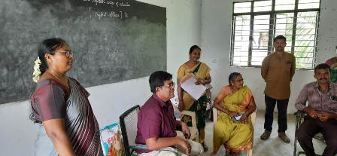
13.10.2022 | Submitted Bills and Accounts of EE Training Programme to DIET office.
14.10.2022 | Submitted Bills and Accounts of EE Training Programme to DIET office.
16.10.2022 | Conducted online meeting through Google Meet- for AASAN AVAI -46th Special programme-DIET & Rotary MOU -Resource Person : Mr.Guru, BT Assistant, PUMS, Addimalaipatti, P.M.Patty Block Salem.  Topic: Interactive Educational Activities
17.10.2022 | PPT Preparation work for DEO meeting was done.
18.10.2022 | BCE Class 12 Taxonomy coordination work was seen.
19.10.2022 | BCE Class 12 Taxonomy coordination work was seen.
20.10.2022 | BCE Class 12 Taxonomy coordination work was seen.
21.10.2022 | BCE Class 12 Taxonomy coordination work –uploaded in web portal.
31.10.2022 | Attended CBT -Essential Programme at Pillar Hall, Madurai

Mr .C.Anbarasan-Lecturer
- 7.10.22- Pre-Planning work was seen for Ennum Ezhuthum-Term II and Fixed venue for training programme.
- 10.10.22 to 12.10.22-Organized and Coordinated “Ennum Ezhuthum” Term-II block level training programme for primary teachers at Kaveri College of Physiotherapy, Mecheri, Salem.
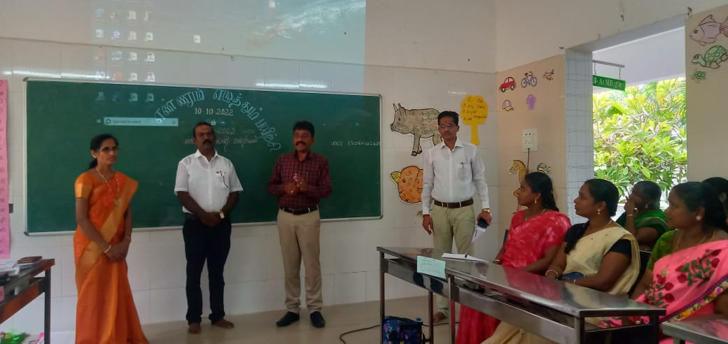
- 18.10.22 to 21.10.22- Coordinated BME Taxonomy work and Data uploaded in web portal at DIET.
Dr K.Kalaivanan-Lecturer
- 7.10.22- Pre-Planning work was seen for Ennum Ezhuthum Term II and Fixed venue for training programme.
- 10.10.22 to 12.10.22-Organized and Coordinated “Ennum Ezhuthum” Term-II block level training programme for primary teachers at G.E.T Matriculation Hr.Sec.School, Gengavalli, Salem.
Mr. K.Satchidanandam - Librarian : (Library)
- 10.10.2022 to 12.10.2022 –Visited and Accompanied with DIET-Principal to all the “Ennum Ezhuthum” training programme centres.
- Arranged (Vasagar Vattam) Library Book Review /Readers Club programme at DIET-Library.
- Day-to-day library activities was seen at library.
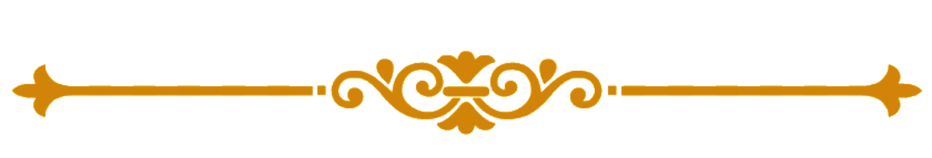
Chief Editor : Dr M.Selvam,
Principal
Uthamacholapuram,
Salem-636010
Edited and Published by : Publication Division
DIET, Salem.
Phone : 7373003460
Website : www.dietsalem.com
Mail Id : dietslm@gmail.com

